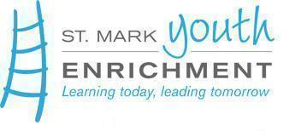
St. Mark After-School Program
Positions

Terms of Employment:
- School year 2026-2027
- Salary: Up to $17.50 per hour, depending on education & experience
- Flexible Program Hours Available: M/T/W/TH/F- 2:30/2:45-5:30 pm, Wednesday’s 1:45 - 5:30/5:40 pm (at our Peosta & Dyersville locations)
- Location Options: Hoover Elementary/3259 St. Anne Dr, Dubuque - Peosta Elementary/8522 Burds Rd, Peosta - Dyersville Elementary/813 12th Ave SW, Dyersville
- In accordance with St Mark Youth Enrichment’s Protection and Safety Policy, a criminal record check will be completed on any applicant selected for this position
- Mandatory Reporter Training required, we provide at no-cost
- Applicants must be 16 years of age to apply

Job Responsibilities: Under the supervision of the Director of Programs & Program Team, school positions assist with the general supervision of children kindergarten through 5th grade in an afterschool setting. We strive to create an after-school environment of safety and belonging by embracing Nature & Social-Emotional Learning (SEL) practices. We achieve this by offering students homework help, unique literacy, and physical activities and access to nature, and community guests sharing hands-on opportunities for students to explore interests in science, technology, engineering, arts, math, and music (STEAM).
To apply for this position, contact Amanda Avenarius at aavenarius@stmarkyouthenrichment.org

